Cinnamon Cafe
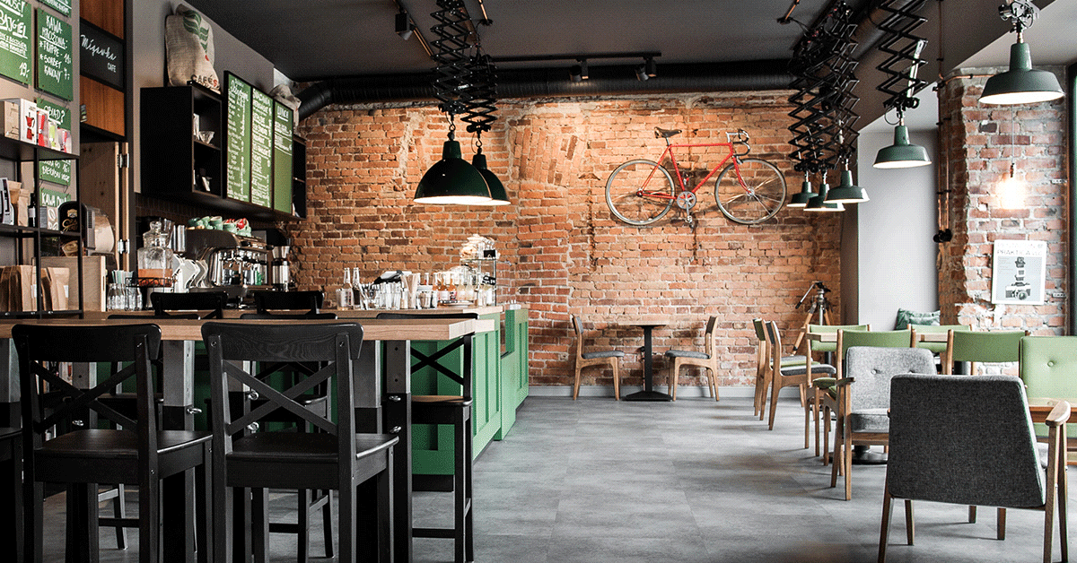

Opening hours
Saturday 08:30 - 15:00
Sunday 10: 30-18: 00
Monday 08:00 - 18:00
Tuesday 08:00 - 18:00
Wednesday 08:00 - 18:00
Thursday 08:00 - 18:00
Friday 08:00 - 18:00

My cafe is unique for several reasons, because we have good coffee, lots of interesting books and you can relax here.
Menu:
Coffee
tea
cakes
Waffles
Sweet pancakes
ice cream desserts
drinks

